DIP MINIPROJECT

Project Title: **Given a sample images master as well as images acquired while undergoing chemical processing to remove material. Find surface area for which the material has been removed (total as well as area under individual hexagon).**

Group members:

Hrishikesh Bhagat 2017BTECS00107

Vishakha Karimungi 2018BTECS00203

Sonam Chaudhari 2018BTECS00205

Methods of cv2 used in this project:

1. cv2.cvtColor(): method is used to convert an image from one color space to another.
2. Cv2.threshold : Thresholding is a very popular segmentation technique, used for separating an object considered as a foreground from its background. A threshold is a value which has two regions on its either side i.e. below the threshold or above the threshold.
3. Cv2.GaussianBlur: The Gaussian filter is a low-pass filter that removes the high-frequency components are reduced.
4. Cv2.findcontours: OpenCV has findContour() function that helps in extracting the contours from the image.
5. Cv2.drawContours: To draw the contours, cv.drawContours function is used. It can also be used to draw any shape provided you have its boundary points. Its first argument is source image, second argument is the contours which should be passed as a Python list, third argument is index of contours (useful when drawing individual contour. To draw all contours, pass -1) and remaining arguments are color, thickness etc.
6. Cv2.pointPolygonTest: This function finds the shortest distance between a point in the image and a contour. It returns the distance which is negative when point is outside the contour, positive when point is inside and zero if point is on the contour.
7. Cv2.resize: Resizing an image means changing the dimensions of it, be it width alone, height alone or both. Also, the aspect ratio of the original image could be preserved in the resized image. To resize an image, OpenCV provides cv2.resize() function.

What we have done in our project:

Steps:

1. We have taken 18 input images for performing this project.
2. Binarized given input images for smoothing effect by Gaussianblur.
3. Detection of contours on original images for drawing rectangle on area where material has been removed.
4. Drawn rectangle around hexagonal plate for calculating surface area of removed element.
5. Focused on foreground image by background subtraction.
6. Applied threshold value to specify reacted area and removed non reacted area.
7. Calculated percentage surface area.

Input image:

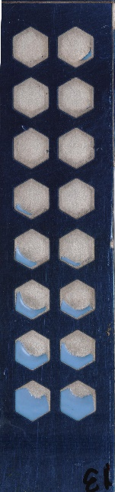

Output Image:

